

**CSC 1300 LAB 9 (Gold & Purple)**

**POINTERS**

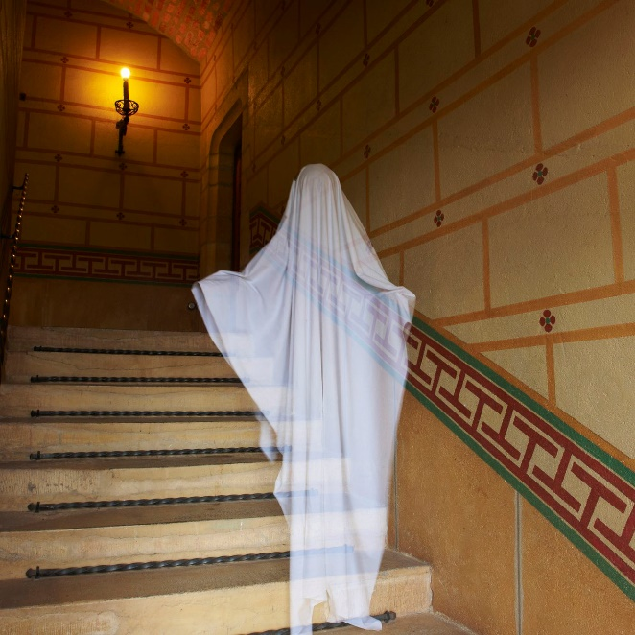

Image of ghost from: <https://www.vox.com/the-goods/2018/10/5/17942874/ghost-hunting-apps-tools-halloween-october>

# Concepts

* Pointers
* Arrays & Pointer Notation
* Dynamic Memory Allocation

# PAIRED PROGRAMMING ASSIGNMENT

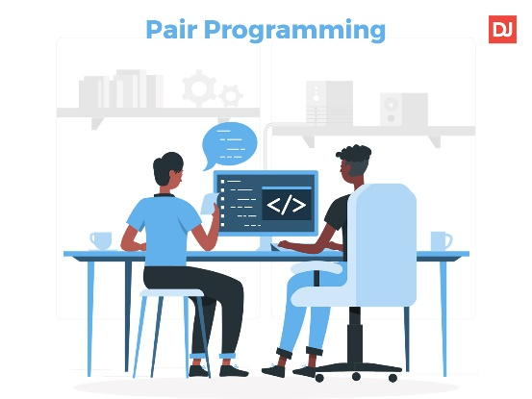**On this assignment, you will be allowed to work with ONE other person!**   
In the comment block at the top of your source file, you must place both names beside “Author: “ to indicate who you worked with. You can’t work with more then one other person. However, you may work alone if you wish.

During paired programming, one person serves as the “**Driver**” and the other serves as the “**Navigator**”. The Driver is the person at the wheel, i.e. the keyboard. They are focused on completing the tiny goal at hand, ignoring larger issues for the moment. A driver should always talk through what they are doing while doing it. The Navigator is in the observer position, while the driver is typing. They review the code on-the-go, give directions and shares thoughts. The navigator also has an eye on the larger issues, bugs, and makes notes of potential next steps or obsticles. The navigator can also help by looking up functions or syntax on reference websites, zybooks, lecture slides, or example programs given in class.

After both partners have read the assignment, decide who will begin as the Driver and Navigator. After 15 minutes, switch roles. Then, after another 15 minutes, switch roles again. The lab instructors will aid in the timing of switching roles. This is very important in paried programming so that both partners are taking responsibility for understanding what is going on in the code.

# specifications

You are the lead investigator of the Crockett Paranormal Society. Create a program that will allow the user to enter the number of investigators in your team as well as data from those investigators including the investigator’s name, the date of their investigation, and how many electronic voice phenomenons (EVPs) they were able to pick up from their audio recorder.

Then, find & print the total and average number of recordings made by all the investigators.

Then, find & print the name, number of recordings, and day of the investigator that logged the most recordings.

**NOTE: The primary purpose of this assignment is to practice using pointers and pointer notation. Therefore, all times when accessing arrays, you must do so using POINTER NOTATION.**

## basic INSTRUCTIONS

1. In your **CSC1300LAB** folder, create a **Lab9** folder.
2. Open **Visual Studio Code (VS Code)**.
3. Click on **File** and then select **Open Folder**. Select the folder that you just created.
4. Create a source file named **lab9.cpp**.
5. Make sure to put a comment block at the top of your code with the filename, author (you & your partner or just you), date, and purpose of the program. Also make sure to put in comments to identify major sections of your code.

## Main Function

### Variables in the Main Function

* An **int** to hold the number of investigators (I refer to it in this assignment as being named **numInvestigators**)
* An **int** to hold the total number of recordings of all investigators.
* A **double** to hold the average number of recordings.
* An **int** to hold the index of the investigator that had the largest amount of recordings.
* A **char** array of size **100**, which will hold the name of the haunted location that was investigated.
* A **pointer to an** **int**, which will eventually point to an array that will hold the number of recordings each investigator had.
* A **pointer to a** **string**, which will eventually point to an array that will hold the name of each investigator.
* A **pointer to a** **string**, which will eventually point to an array that will hold the date that the investigator made the recordings (performed their investigation).

### Main Function Directions

* Ask the user for the location the are investigating and read in the user’s input to the **character array (c-string).**
* Ask the user for the number of investigators at the location and read it into the integer variable.
* Validate that the number entered is at least 1 but not greater than 25.
* Dynamically allocate (syntax below) the three arrays – an integer array holding the number of recordings (evps), a string array holding the names of the investigators, and a string array holding the date of their investigation.

**intPtr = new int[numInvestigators]; //intPtr is the name of the integer pointer parameter**

* Call the **getParanormalData** function, sending the number of investigators and the three pointers that point to the three arrays.
* Call the **getStats** function, sending the number of investigators, the **pointer to the int** array, the memory address of the total (**int**) variable, the memory address of the average (**double**) variable, and the memory address of the highest index (**int**) variable.
* Print the results to the screen in a nice, readable way like the sample output. (Remember to access arrays using pointer notation)
* Release the three dynamically allocated arrays. Note the arrays were created in the “createArrays” function, but it isn’t until the end of the main function that we are done with the arrays so this is where the memory should be released. To release an array you use the following syntax:

**delete [] ptrName;** **//ptrName is the pointer that holds the memory address of the array**

## Programmer-defined Functions

### getParanormalData

**Return type:** void

**Parameters:**

* An **int** holding the number of investigators (**numInvestigators**).
* A **pointer to an** **int**, which points to an **array** that holds the number of recordings each investigator had (**evps**)
* A **pointer to a** **string**, which points to an **array** that holds each investigator **name**.
* A **pointer to a** **string**, which points to an **array** that holds the **dates** of investigation

**Purpose:** this function will iterate through each element of the array and allow the user to enter in each investigator’s name, day of investigation, and number of EVPs.

**NOTE: Accessing arrays must be in pointer notation!**

### getStats

**Return type:** **void**

**Parameters:**

* An **int** holding the number of investigators (**numInvestigators**)
* A **pointer to an** **int**, which points to an **array** that holds the number of recordings (**evps**) each investigator had.
* A **pointer to an int** to hold the memory address of the **total** variable from main
* A **pointer to a double** to hold the memory address of the **average** variable from main
* A **pointer to an int** to hold the memory address of the index of the investigator with the most recordings (**highestIndex**) variable from main

**Purpose:** this function will find the total number of recordings of EVPs by all investigators and the index of the investigator that had the most recordings (highestIndex). Then it will find the average number of recordings by the investigators.

**NOTE: Accessing arrays must be in pointer notation!**

# sample output

## Sample Output 1

User input is highlighted in **yellow**.

**Hello! What haunted location are you investigating?**

**Ohio State Penitentiary**

**How many investigators will be working this location?**

**30**

**Oops! You must enter 1 through 25.**

**How many investigators will be working this location?**

**-4**

**Oops! You must enter 1 through 25.**

**How many investigators will be working this location?**

**5**

**Enter the investigator's name, the day of their investigation, and the number of EVPs they recorded on their voice recorder.**

**INVESTIGATOR 1:**

**NAME - April Crockett**

**DAY (ex: 04-03-2023) - 01-03-2023**

**NUMBER OF EVPs - 87**

**INVESTIGATOR 2:**

**NAME - Jason Crockett**

**DAY (ex: 04-03-2023) - 01-03-2023**

**NUMBER OF EVPs - 38948**

**INVESTIGATOR 3:**

**NAME - Dwight Shrute**

**DAY (ex: 04-03-2023) - 02-14-2023**

**NUMBER OF EVPs - 384**

**INVESTIGATOR 4:**

**NAME - Bob Ross**

**DAY (ex: 04-03-2023) - 02-14-2023**

**NUMBER OF EVPs - 9388**

**INVESTIGATOR 5:**

**NAME - Clarence Wendle**

**DAY (ex: 04-03-2023) - 04-07-2023**

**NUMBER OF EVPs – 384**

**-----------------------------------------------------------------**

**The total amount of EVPs recorded by all 5 investigators at**

**Ohio State Penitentiary is 49191 recordings.**

**The average amount of EVPs recorded at Ohio State Penitentiary**

**is 9838.2 recordings.**

**The investigator who recorded the most (38948 recordings)**

**is Jason Crockett on 01-03-2023!!**

**-----------------------------------------------------------------**

## Sample Output 2

User input is highlighted in **yellow**.

**Hello! What haunted location are you investigating?**

**Tennessee Tech Bruner Hall**

**How many investigators will be working this location?**

**3**

**Enter the investigator's name, the day of their investigation, and the number of EVPs they recorded on their voice recorder.**

**INVESTIGATOR 1:**

**NAME – Moumita Kamal**

**DAY (ex: 04-03-2023) - 03-29-2023**

**NUMBER OF EVPs - 943**

**INVESTIGATOR 2:**

**NAME – Cyril Focht**

**DAY (ex: 04-03-2023) - 03-30-2023**

**NUMBER OF EVPs - 597**

**INVESTIGATOR 3:**

**NAME - April Crockett**

**DAY (ex: 04-03-2023) - 04-01-2023**

**NUMBER OF EVPs - 1542**

**-----------------------------------------------------------------**

**The total amount of EVPs recorded by all 3 investigators at**

**Tennessee Tech Bruner Hall is 3082 recordings.**

**The average amount of EVPs recorded at Tennessee Tech Bruner Hall**

**is 1027.33 recordings.**

**The investigator who recorded the most (1542 recordings)**

**is April Crockett on 04-01-2023!!**

**-----------------------------------------------------------------**

# What to Turn In

ZIP & upload **lab9.cpp** to the Lab 9 ilearn assignment. All students must submit, even if you worked with another student (both students submit). **It is ok that both student’s submissions be identical. However, more then two students shouldn’t have identical code.**